LAB 5

EX1:

EX2:

EX3:

EX4:

EX5:

EX6:

EX7:

Ex_ 8

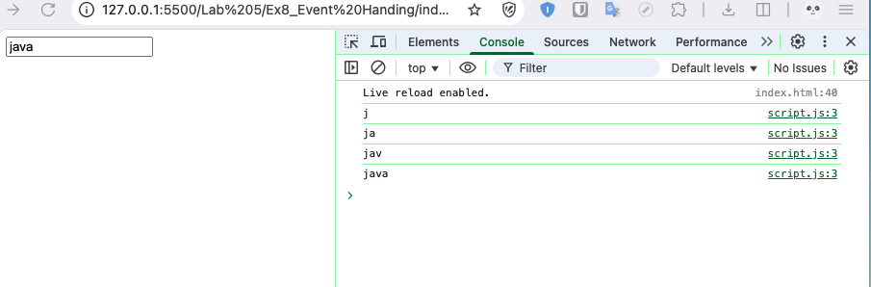

Ex_ 9

Ex10_ Using ES+ Features

Ex11

E12_Simple Animation

E13:

Ex14: Form Validation

EX15:

EX16:

EX17:

Ex18

BT1:

BT2:

BT3:

BT4

